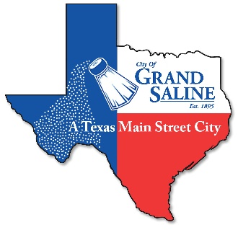 CITY OF GRAND SALINE
132 East Frank Street Grand Saline, TX 75140 Phone: (903) 962-3122 Fax: (903) 962-3363

GARAGE SALE PERMIT

NAME:________________________________ PHONE:________________________________

ADDRESS OF SALE:____________________________________________________________

GARAGE SALE DATES & HOURS:_________________________________________________

GARAGE SALE _____ OF 2 FOR _________ $10.00_________________________________

APPROVED BY:_____________________________ DATE:______________________________

______SIGNS NOT ALLOWED ON UTILITY POLES OR IN RIGHT-OF-WAYS

______SIGNS MUST BE REMOVED AFTER GARAGE SALE

______IF FOUND IN NON-COMPLIANCE, A CITATION MAY BE ISSUED

______ FINES COULD BE UP TO $500.00

______ ORDINANCES CAN BE FOUND ONLINE WWW.GRANDSALINETX.GOV

______ ORDINANCE 2004-111

______ ORDINANCE 2015-109

______ ORDINANCE 2023-101

Signed:_______________________________________________

